UX Case Study: Optimizing the Checkout and Navigation Flow in Zomato
Submitted by:
Mitushi Jain
Internship Program: CodeAlpha Internship
Task Number: Task 3: UX Case Study
Date: June 13, 2026

User Journey Analysis
The user journey for ordering food involves several critical touchpoints:
- App Launch & Search: The user opens the app to find a specific cuisine or restaurant.
- Menu Navigation: The user selects a restaurant and scrolls through menu items.
- Cart & Checkout: The user reviews items, applies coupons, and proceeds to payment.
- Order Tracking: The user monitors the delivery status in real-time.

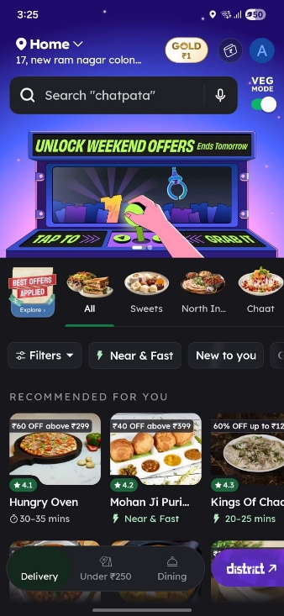

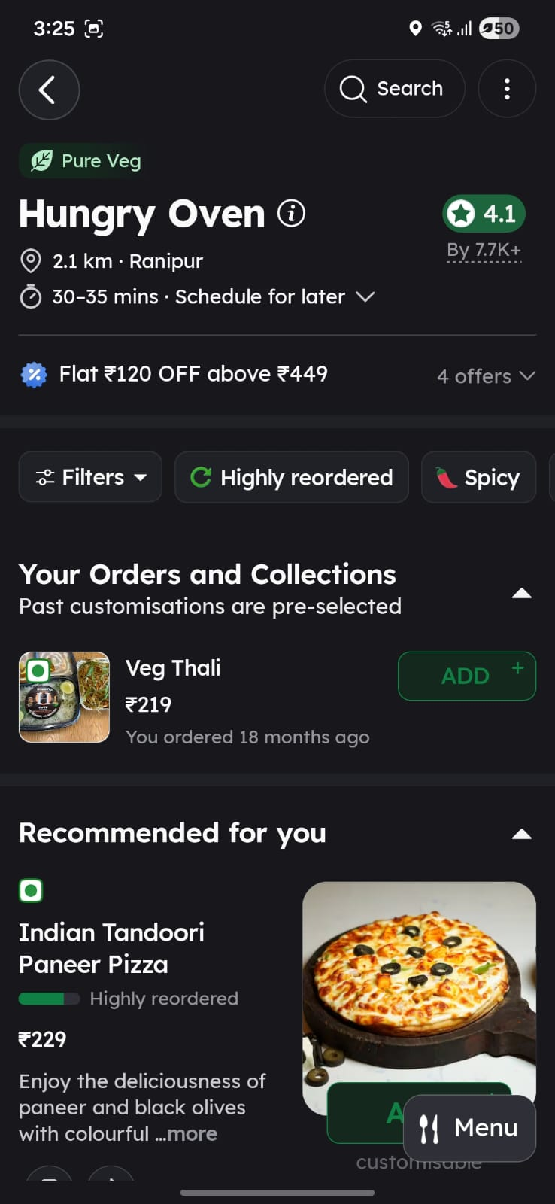
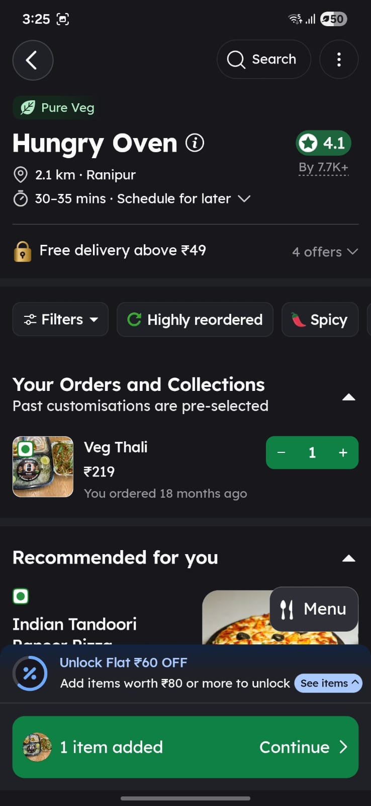
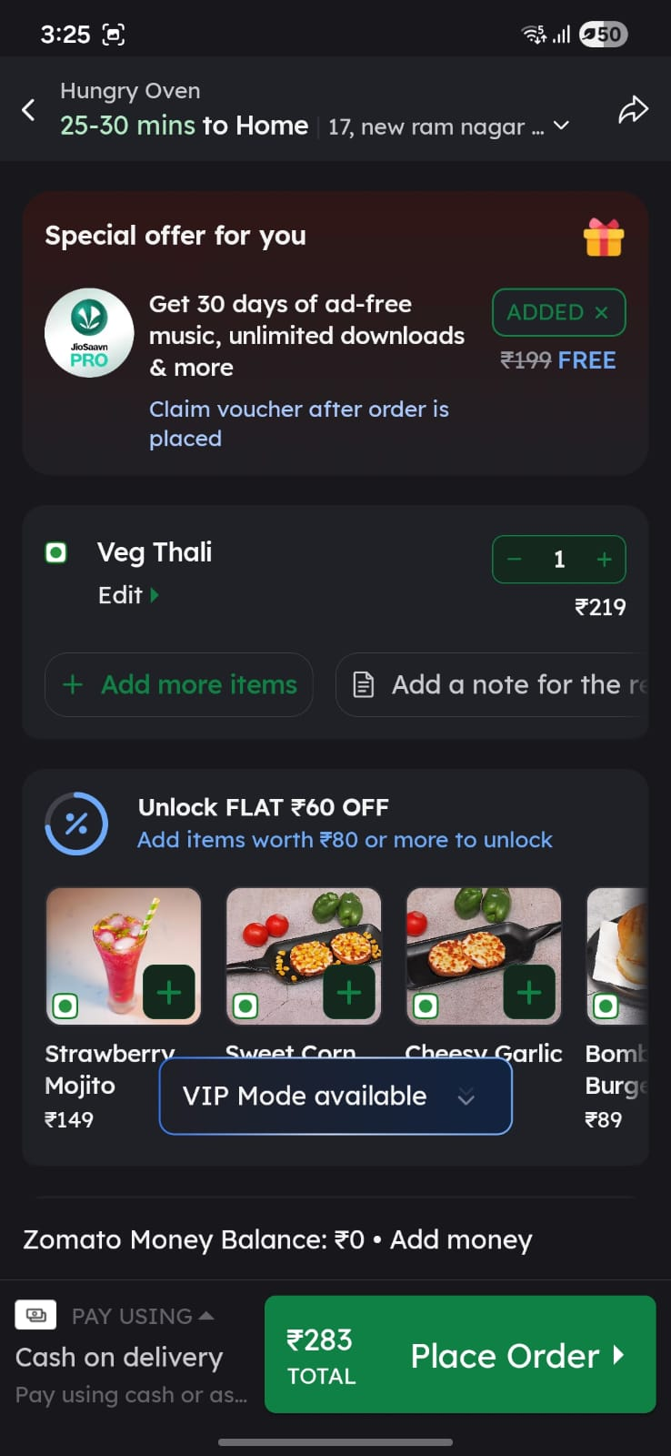

Strengths and Weaknesses
Strengths
- The visual layout of the menu is highly engaging with clear images.
- The search functionality is robust, offering quick results based on history.
Weaknesses (Pain Points)
- Coupon Complexity: Users often find it difficult to locate the "Apply Coupon" button during the checkout process.
- Notification Overload: Frequent push notifications can lead to user frustration.
- Status Ambiguity: During peak hours, the delivery tracking updates can be inconsistent, leading to user anxiety.

Proposed Improvements
Based on the analysis, I suggest the following three improvements:
- Streamlined Checkout: Move the "Apply Coupon" section to the top of the order summary to increase visibility.
- Notification Management: Introduce a "Notification Settings" dashboard that allows users to toggle specific categories of alerts.
- Enhanced Tracking UI: Implement a more descriptive delivery status bar that provides granular updates, such as "Order at Kitchen" vs "Order at Counter".

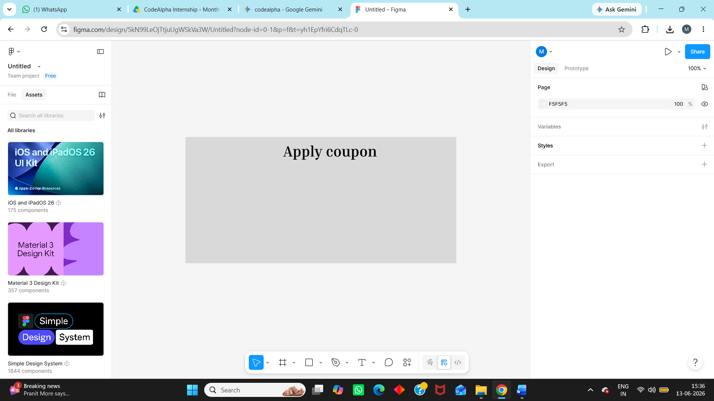

Conclusion
By addressing these friction points, the platform can significantly improve user retention and satisfaction. The proposed changes focus on transparency and simplicity, ensuring that the transition from selection to delivery is as smooth as possible for the end-user.

